The Era of the Great War, 1910–1928
- Scots on the Western Front
- Recruitment;
- Experience of life in the trenches;
- Military tactics; war of attrition
- Technology of war — gas, tanks, machine guns, aircraft, artillery

- Domestic impact of war: society and culture
- Food restrictions and what action the government took
- Changing role of women;
- Propaganda;
- Conscription and conscientious objectors;
- Casualties and deaths.

- Domestic impact of war: industry and economy
- Industry during the war
- Reserved occupations;
- Post-war decline of heavy industry;
- New industries in the 1920s

- Domestic impact of war: politics
- Campaigns for women’s suffrage;
- Defence of the Realm Act;
- Rent strikes;
- Homes fit for heroes
- Red Clydeside

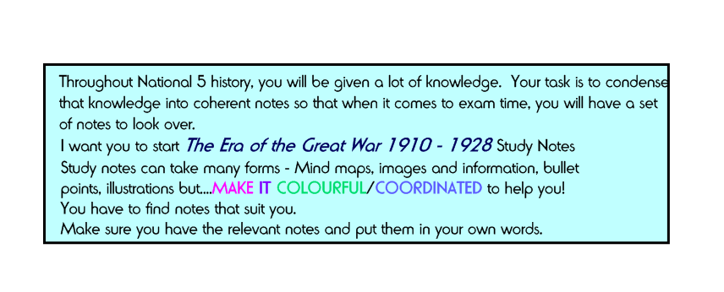
Due – 31st October 2016

